**22AIE457 - Full Stack Development**

**Lab Report III – Fundamentals of HTML & CSS**

**Introduction**

This lab exercise introduces the foundational concepts of web development using HTML and CSS. The experiments progress from creating a basic HTML document to designing a static multi-page website with frames, and finally incorporating CSS for styling and interactivity. Each experiment serves to build core skills necessary for modern full-stack development, with particular emphasis on semantic tags and layout design.

1. **Basic Structure of an HTML Document**

**Code:**

<!DOCTYPE html>

<html>

<head>

    <title>My First Webpage</title>

</head>

<body>

    o

    <h1>Welcome to My Webpage</h1>

    <!-- Subheading -->

    <h2>About This Page</h2>

    <p>This is a simple webpage created using basic HTML commands only.</p>

    <!-- A division section -->

    <div>

        <h2>Favorite Things</h2>

        <!-- Unordered List -->

        <ul>

            <li>Reading</li>

            <li>Coding</li>

            <li>Traveling</li>

        </ul>

        <!-- Ordered List -->

        <h3>Steps to Create a Webpage</h3>

        <ol>

            <li>Start with DOCTYPE and HTML tags</li>

            <li>Add head and body</li>

            <li>Include content with tags</li>

        </ol>

    </div>

    <!-- Definition List -->

    <h2>Terms</h2>

    <dl>

        <dt>HTML</dt>

        <dd>Hypertext Markup Language</dd>

        <dt>CSS</dt>

        <dd>Cascading Style Sheets</dd>

    </dl>

    <!-- Links -->

    <h2>Links</h2>

    <p><a href="https://en.wikipedia.org/wiki/Sample">Visit Example</a></p>

    <p><a href="sample@gmail.com">Send Email</a></p>

    <p><a href="tel:+1234567890">Call Us</a></p>

    <p><a href="C:\Users\CH.EN.U4AIE22036\Desktop\Sample.zip" download>Download File</a></p>

    <!-- Image -->

    <h2>Sample Image</h2>

    <img src="C:\Users\CH.EN.U4AIE220036\Pictures\Screenshots\Screenshot 2025-07-04 090001.png" alt="A sample image">

    <br> <!-- Line break -->

    <hr> <!-- Horizontal rule -->

    <!-- Form -->

    <h2>Contact Us</h2>

    <form>

        <label for="name">Name:</label>

        <input type="text" id="name" name="name"><br><br>

        <label for="email">Email:</label>

        <input type="email" id="email" name="email"><br><br>

        <input type="submit" value="Submit">

    </form>

</body>

</html>

**Output:**

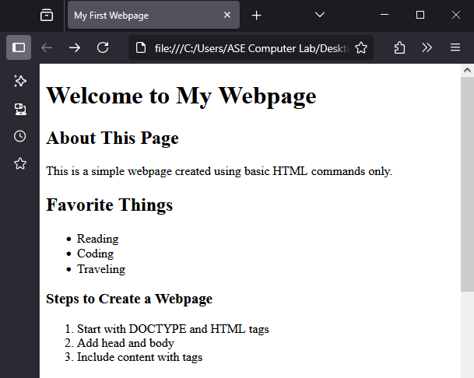 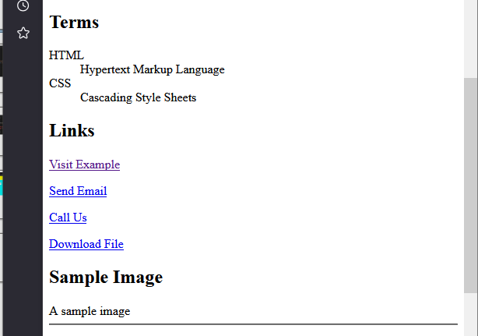

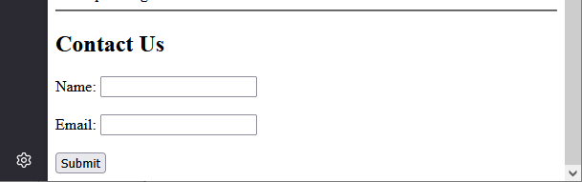

**Inference:**

1. This section demonstrates how to create a complete HTML document structure with essential elements like headings, lists, links, images, and forms.
2. Lists: <ul>, <ol>, <dl> represents unordered, ordered, and definition lists respectively. These are Useful in content organization and readability.
3. Link tags <a href="..."> acts as Hyperlink to email (mailto:), call (tel:), file download, and websites. Demonstrates multi-protocol linking capability.
4. <img> and <br>, <hr> introduces multimedia and basic spacing tools.
5. Form Elements: <form>, <input>, <label>, capture user input and initiate submission. These are the foundation for interactive and dynamic websites.
6. **Designing a Static Web Page**

**Code:**

**home.html**

<html>

<head>

<frameset rows="20%,80%">

<frame name="title" src="titlepage.html">

<frameset cols="25%,75%">

<frame name="list" src="list.html">

<frame name="display" src="display.html">

</frameset>

</frameset>

</head>

</html>

**titlepage.html**

<html>

<head>

<title>title page</title>

</head>

<body bgcolor="yellow" text="red">

<h1 align="center"> ONLINE BOOK STORE </h1>

</body>

</html>

**list.html**

<html>

<head>

<title> List</title>

</head>

<body bgcolor="pink">

<center>

<a href="login.html" target="display"><b> LOGIN </b></a><br>

<a href="catalogue.html" target="display"><b> CATALOGUE </b></a>

</center>

</body>

</html>

**left.html**

<html>

<head>

<title>Top Page</title>

</head>

<body>

<a href="cse.html" target="body">CSE</a><br />

<a href="ece.html" target="body">ECE</a><br />

<a href="eee.html" target="body">EEE</a><br />

<a href="civil.html" target="body">CIVIL</a><br />

</body>

</html>

**login.html**

<html>

<body bgcolor="cyan">

<h2 align="center">LOGIN PAGE</h2>

<center>

<form>

<table border="1">

<tr>

<td><label>USER NAME</label></td>

<td><input type="text" name="uname"></td>

</tr>

<tr>

<td><label>PASSWORD</label></td>

<td><input type="password" name="pwd"></td>

</tr>

<tr>

<td><input type="submit" value="LOGIN"></td>

</tr>

</table>

</form>

</center>

</body>

</html>

**catalogue.html**

<html>

<body bgcolor="orange" >

<h1 align="center">CATALOGUE PAGE</h1>

<center>

<table border="1">

<tr>

<th> COVER IMAGE</th>

<th> AUTHOR NAME</th>

<th> TEXT BOOK-NAME</th>

<th> PRICE</th>

<th> ADD TO CART</th>

</tr>

<tr>

<td><imgsrc="c#.jpg" height="105" width="150"></td>

<td>Harsh Bhasin</td>

<td> Programming in C#</td>

<td>200/</td>

<td><input type="button" value="ADD TO CART"</td>

<tr>

<td><imgsrc="cn.jpg" height="105" width="150"></td>

<td>Andrew S Tanenbaum</td>

<td>Computer Networks</td>

<td>400/</td>

<td><input type="button" value="ADD TO CART"</td>

<tr>

<td><imgsrc="wt.jpg" height="105" width="150"></td>

<td>Chris Bates</td>

<td>Web Programming, Building Internet Applications</td>

<td>599/</td>

<td><input type="button" value="ADD TO CART"</td>

<tr>

<td><imgsrc="wt1.jpg" height="105" width="150"></td>

<td>Kogent</td>

<td>Web Technologies, Black book</td>

<td>499/</td>

<td><input type="button" value="ADD TO CART"</td>

</table>

</center>

</bdoy>

</html>

**display.html**

<html>

<head>

<title>display</title>

</head>

<body bgcolor="blue" text="white">

<h2 align="center">DISPLAY</h2>

</body>

</html>

**Output:**

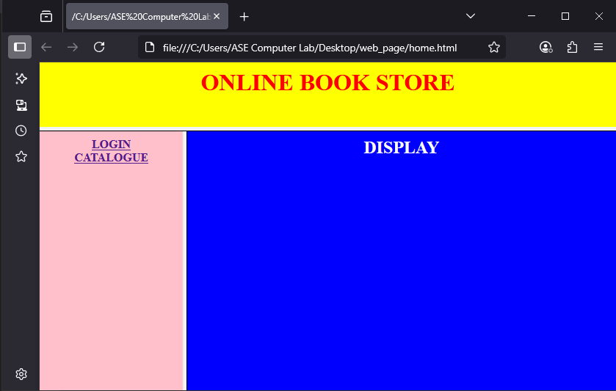

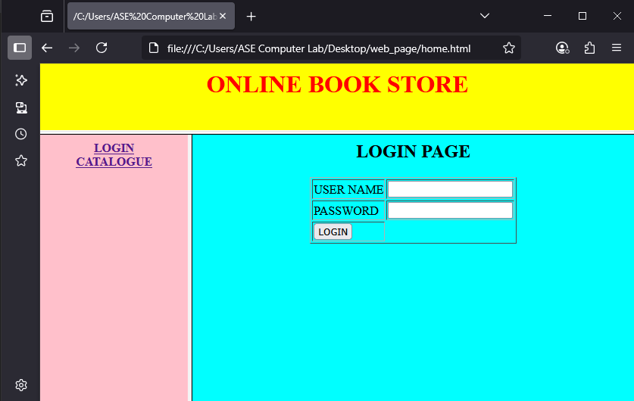

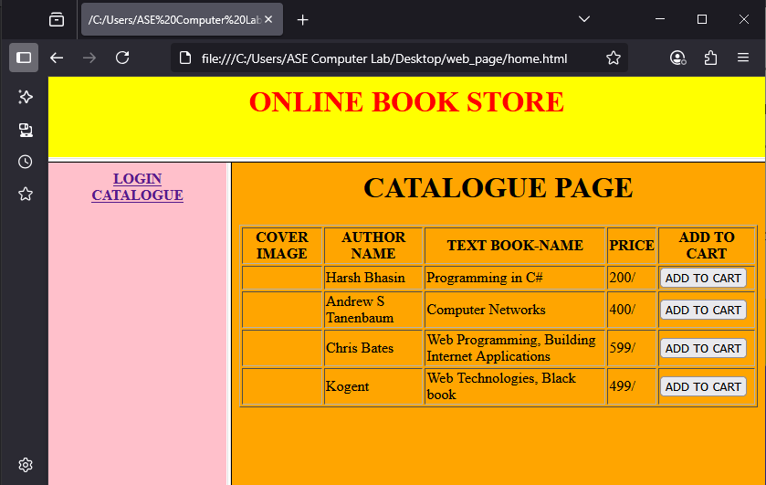

**Inference:**

1. This section demonstrates the use of the <frameset> and <frame> tags to divide a webpage into distinct sections arranged in rows and columns.
2. It enables independent loading and viewing of multiple HTML documents within the same browser window, enhancing modular design.
3. Although <frameset> is deprecated in HTML5, it is still useful for understanding older layout techniques in static web design.
4. The navigation system implemented in list.html uses the target="display" attribute to dynamically load pages into a designated frame without refreshing the entire layout.
5. The section includes separate pages like login.html, catalogue.html, and display.html, each functioning independently within frames.
6. The catalogue.html file uses tables and buttons to simulate a basic online bookstore interface, demonstrating form controls and structured data presentation.

**3. Designing Web Page using CSS**

**Code:**

**fontstyle.html**

<!DOCTYPE html>

<html lang="en">

<head>

    <meta charset="UTF-8">

    <meta name="viewport" content="width=device-width, initial-scale=1.0">

    <title>Web Page with CSS Styling</title>

    <!-- Link to all CSS files -->

    <link rel="stylesheet" href="font.css">         <!-- For font and text styles -->

    <link rel="stylesheet" href="background.css">   <!-- For background settings -->

    <link rel="stylesheet" href="layers.css">       <!-- For layering elements -->

    <link rel="stylesheet" href="cursor.css">       <!-- For custom cursors -->

</head>

<body>

    <!-- Text examples with different styles -->

    <p class="center">This is text with Arial font style.</p>

    <p class="right">This is text with Calibri font style.</p>

    <p class="left">This is text with Cooper font style.</p>

    <!-- Links with different styles -->

    <a href="#" class="xlink">Crosshair Link</a><br>

    <a href="#" class="hlink">Help Link</a>

    <!-- Background and Layering -->

    <h1 class="heading">Web Technology</h1>

    <div class="layer1">Layer 1 Content</div>

    <div class="layer2">Layer 2 Content</div>

    <!-- Cursor examples -->

    <p class="cursor-example not-allowed">This is a not-allowed cursor.</p>

    <p class="cursor-example progress">This is a progress cursor.</p>

</body>

</html>

**background.css**

/* background.css */

body {

    background-image: url('wt.jpg');      /* Replace 'wt.jpg' with your actual image path */

    background-repeat: repeat;            /* Tiling behavior */

    background-color: pink;               /* Fallback color if the image is not found */

}

h1 {

    background-image: url('wt1.jpg');     /* Background image for h1 */

    background-repeat: no-repeat;

    background-position: right;

    color: red;

}

**font.css**

/* font.css */

p.center {

    color: pink;

    text-align: center;

    font-family: Arial, sans-serif;

    font-weight: bold;

    letter-spacing: 3px;

}

p.right {

    color: orange;

    text-align: right;

    font-family: Calibri, sans-serif;

    font-weight: bold;

    letter-spacing: 10px;

}

p.left {

    color: green;

    text-align: left;

    font-family: "Cooper Black", sans-serif;

    font-weight: bold;

    letter-spacing: 15px;

}

**layers.css**

/* layers.css */

.layer1 {

    position: relative;

    z-index: 2;

    background-color: blue;

    color: white;

    font-size: 50px;

    height: 100px;

    top: 0;

    left: 0;

}

.layer2 {

    position: relative;

    z-index: 1;

    background-color: green;

    color: white;

    font-size: 60px;

    height: 100px;

    top: -50px;

    left: 50px;

}

**cursor.css**

/* cursor.css */

.xlink {

    cursor: crosshair;

}

.hlink {

    cursor: help;

}

.cursor-example.not-allowed {

    cursor: not-allowed;

}

.cursor-example.progress {

    cursor: progress;

}

.cursor-example.wait {

    cursor: wait;

}

.cursor-example.zoom-in {

    cursor: zoom-in;

}

.cursor-example.zoom-out {

    cursor: zoom-out;

}

.cursor-example.no-drop {

    cursor: no-drop;

}

.cursor-example.move {

    cursor: move;

}

.cursor-example.default {

    cursor: default;

}

.cursor-example.scroll {

    cursor: scroll;

}

.cursor-example.crosshair {

    cursor: crosshair;

}

.cursor-example.help {

    cursor: help;

}

**Output:**

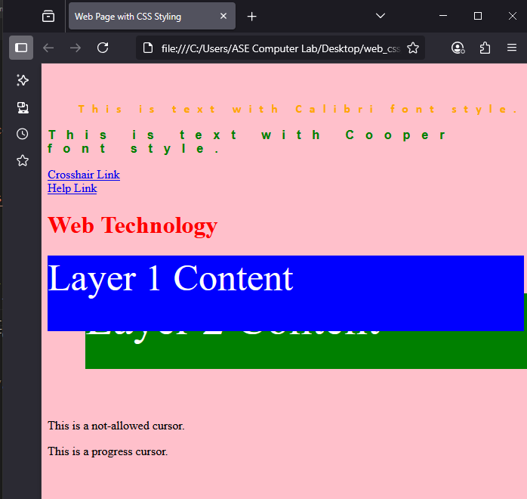

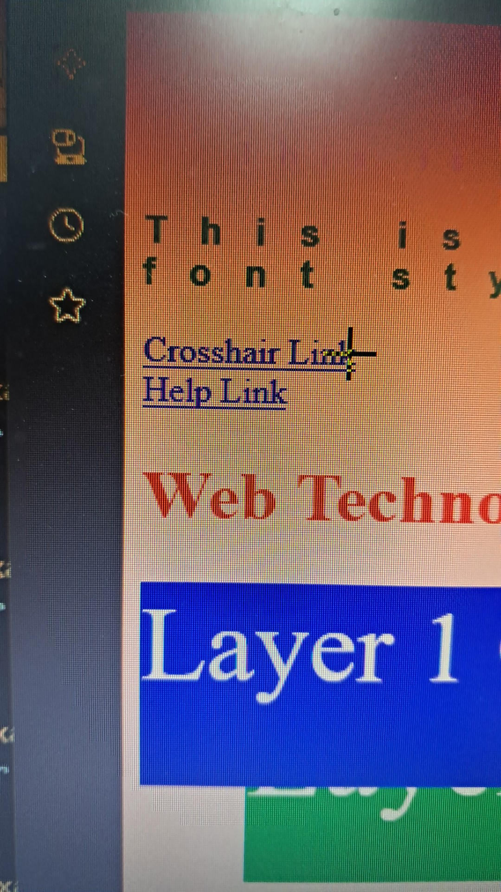 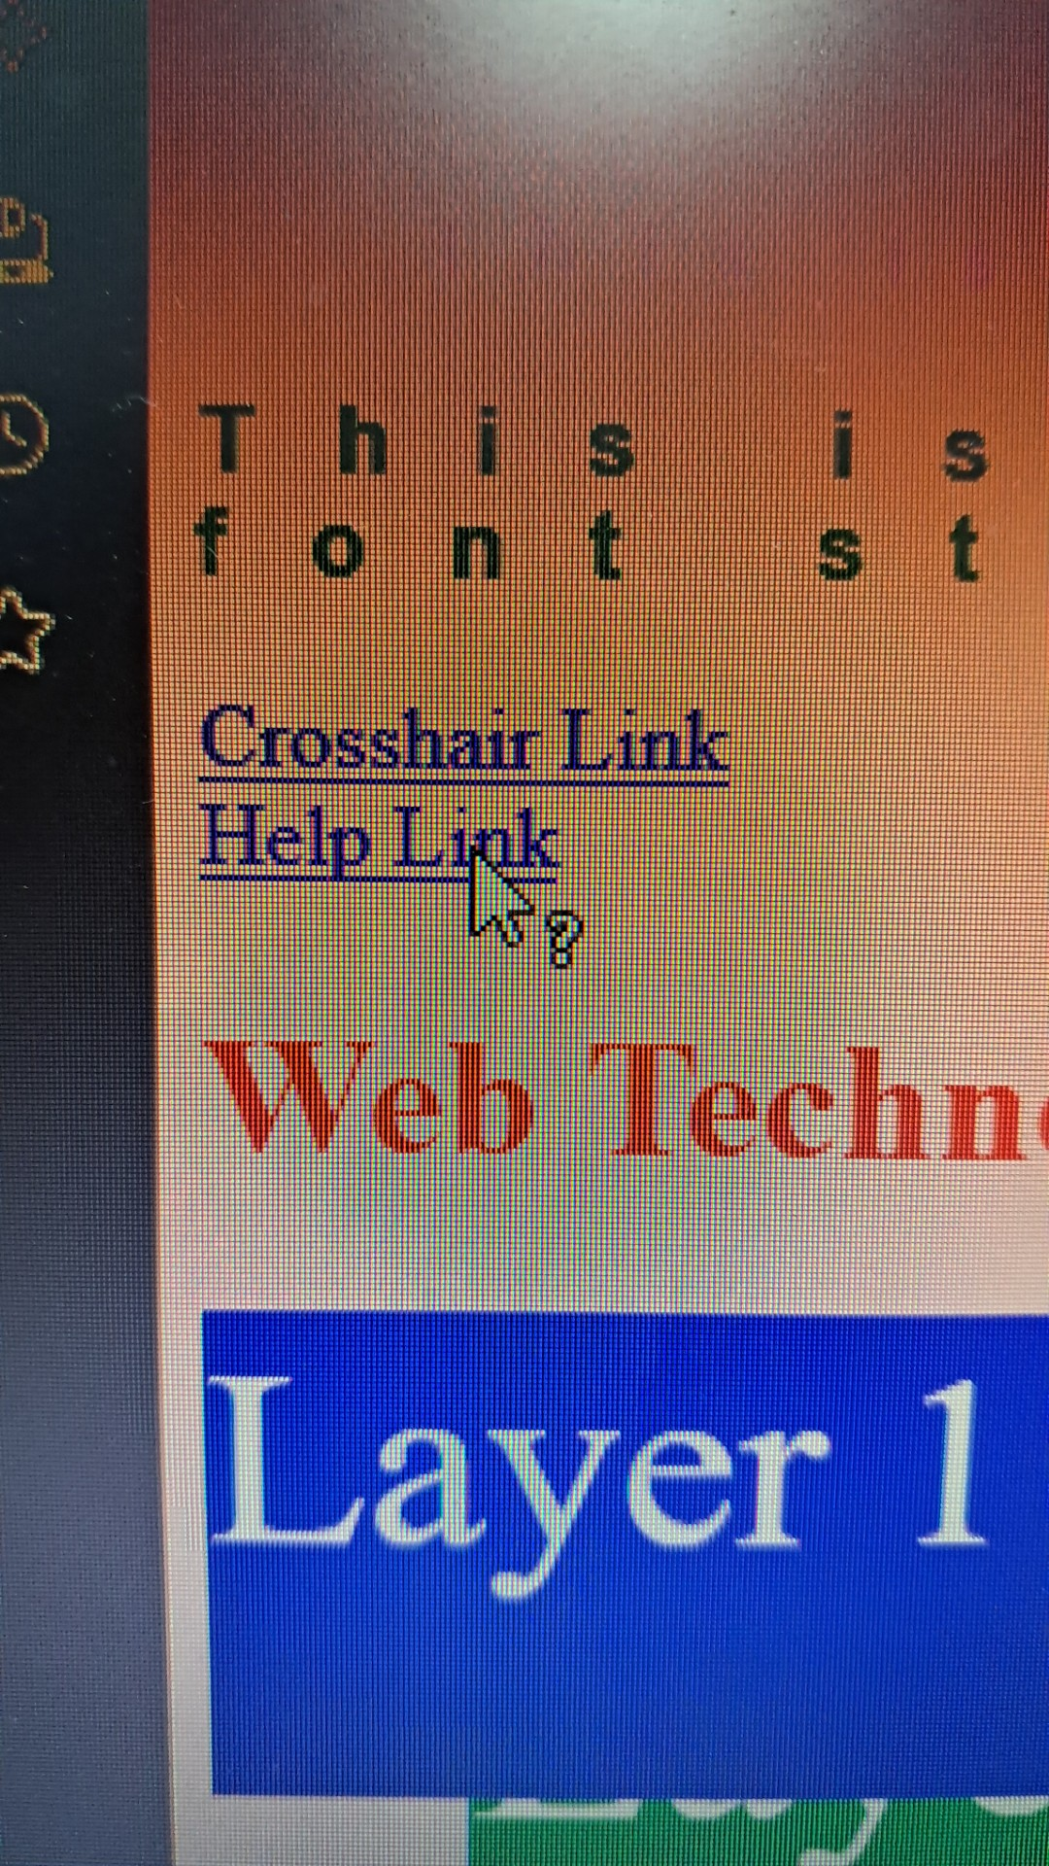

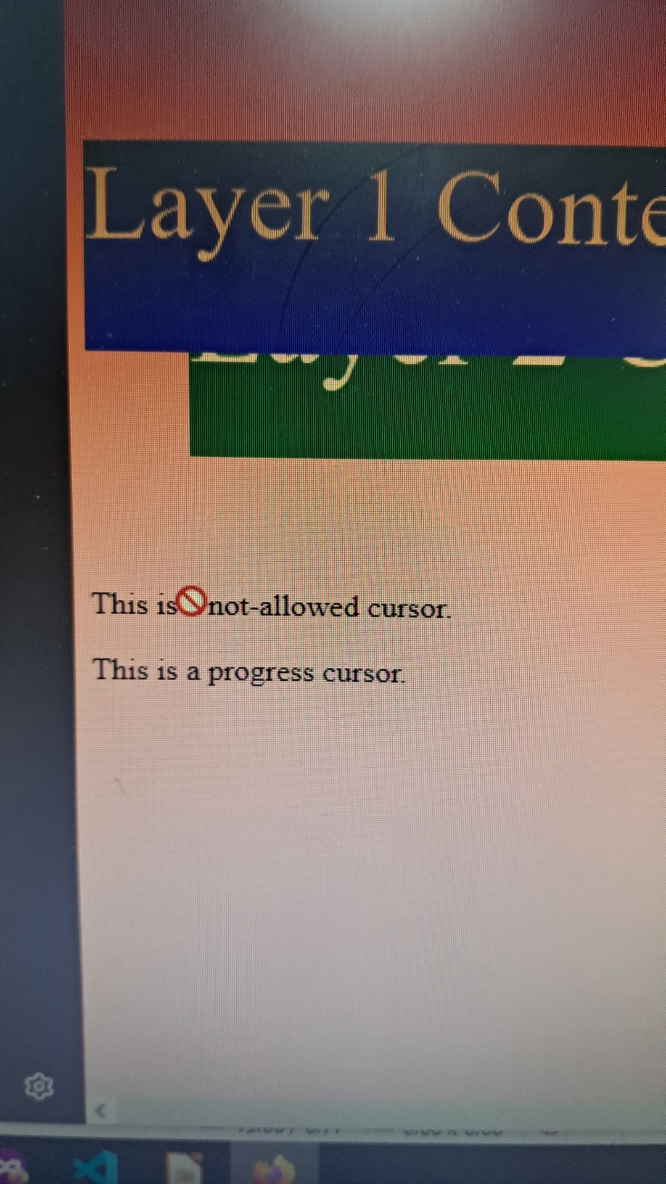 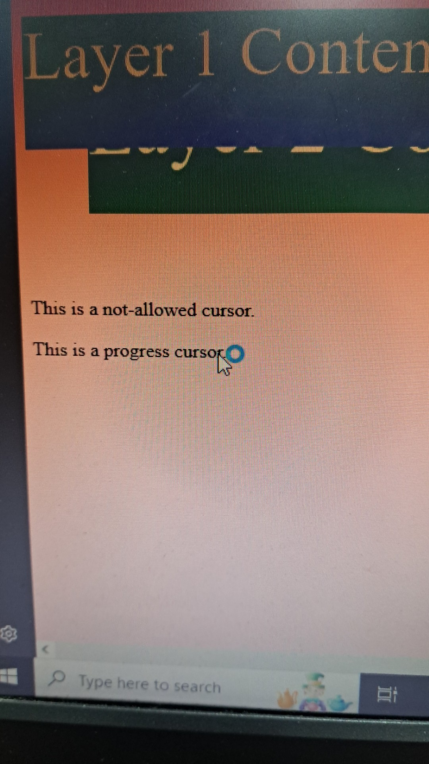

**Inference:**

1. This section highlights the use of modular CSS to cleanly separate presentation from structure, improving code maintainability and scalability.
2. Multiple external CSS files are linked (font.css, background.css, layers.css, cursor.css), each handling a distinct aspect of styling.
3. Typography is customized using properties like font-family, text-align, and letter-spacing through class selectors, enhancing text readability and layout alignment.
4. Background customization with images and fallback colors improves aesthetic appeal and ensures visual consistency even when images fail to load.
5. Layered content is managed using z-index, position, and offset values, enabling practical use cases such as popups, overlays, and depth perception in UI.
6. Custom cursors such as crosshair, progress, and not-allowed provide interactive visual feedback, enhancing the overall user experience.
7. The use of these specialized CSS classes is essential for building clean, interactive, and responsive user interfaces with controlled layout and enhanced accessibility.

**Conclusion:**

This lab experiment effectively covers the step-by-step progression from basic HTML structures to advanced styling with CSS. Each section highlights not only syntax and functionality but also emphasizes the **importance of semantic design, user interactivity, and modular styling**. The use of special tags illustrates the **versatility of web technologies** and help in building user-friendly, maintainable, and scalable web applications.